**Algorithm**

In programming, algorithm is a set of well-defined instructions in sequence to solve the problem.

## Qualities of a good algorithm

1. Input and output should be defined precisely.
2. Each step in algorithm should be clear.
3. Algorithm should be most effective among many different ways to solve a problem.

## Examples Of Algorithms In Programming

**1) Write an algorithm to add two numbers entered by user.**

Step 1: Start

Step 2: Declare variables num1, num2 and sum.

Step 3: Read values num1 and num2.

Step 4: Add num1 and num2 and assign the result to sum.

sum←num1+num2

Step 5: Display sum

Step 6: Stop

**2) Write an algorithm to find the largest among two different numbers entered by user.**

Step 1: Start

Step 2: Declare variables num1,num2

Step 3: Read variables num1,num2

Step 4: If num1>num2

Display num1 is the largest number.

Else

Display num2 is the largest number.

Step 5: Stop

**Flow Chart**

**What is a Flowchart?**  
Flowchart is a diagrammatic representation of an algorithm. Flowchart is very helpful in writing program and explaining program to others.

## Symbols Used In Flowchart

Different symbols are used for different states in flowchart, For example: Input/output and decision making has different symbols. The table below describes all the symbols that are used in making flowchart

|  |  |  |
| --- | --- | --- |
| Symbol | Purpose | Description |
|  | Flow line | Used to indicate the flow of logic by connecting symbols. |
|  | Terminal(Stop/Start) | Used to represent start and end of flowchart. |
|  | Input/Output | Used for input and output operation. |
|  | Processing | Used for airthmetic operations and data-manipulations. |
|  | Desicion | Used to represent the operation in which there are two alternatives, true and false. |
|  | page Connector | Used to join different flowline |

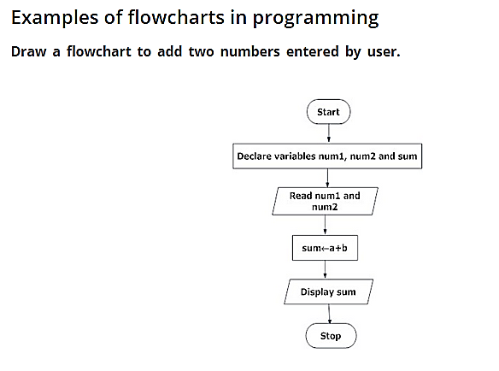

**Flow Chart to find largest of two numbers**

